
This work was prepared and submitted in fulfillment of academic requirements of the GIS certificate program of the Dutton E-education Institute at Penn State University (PSU) https://www.education.psu.edu. These findings imply no endorsement by PSU.

.

An Overview of GIS Clearinghouses in the Context of
Community Emergency Management
A. Jon Allred

Abstract: This white paper reports the tacit status of all apparent U.S. state-sponsored GIS clearinghouses in terms of readiness to support local pre-disaster mitigation planning and event response. Among findings, GIS clearinghouses provide almost universal, no-cost access to extensive spatial data in many formats. However, resources are largely organized by source rather than use, and user map production services are nascent. In contrast, Federal agency efforts promote uniformity of metadata, a seamless national map, organization by overt purposes and support for user participation in GIS development. The proliferation of spatial-capable mobile devices portends the migration of GIS toward non-technical, mass application. A Web page by the author provides further backdrop for considering GIS resources in community emergency planning and response.

Introduction

This white paper examines the apparent condition of state-sponsored GIS clearinghouses in terms of readiness to support community emergency planning and response.

As of 2006, the information economy is burgeoning, location services and GIS are axiomatic and increasingly transparent. Performance is measured by leaps in speed, flexibility and content richness. The latest mobile devices may package voice, video, GPS and Internet capabilities. Trends suggest a new spatiality in which GIS is more distributed than centralized, more fluid than static, and increasingly user-based rather than ‘top-down’ or client-served. Increasingly, electronic communication overcomes barriers to culture, language, geography, wealth and technical education. The evolution of spatial tools is also illustrated by the increasing frequency with which GIS figures in both planning and response to emergency events, most recently Hurricane Katrina in 2005 and the Indian Ocean tsunami in 2004.

Investigation

Community emergencies have a spatial component, and GIS is ubiquitous in pre-disaster planning: inventories of assets, ranking of risks, identification of danger zones and choke points, and routing for deployment of resources during inclement events. As such, this paper describes the results of cursory queries of primary GIS clearinghouses in each of the 50 U.S. states in terms of accessibility, speed, flexibility, richness, comprehension and permeability. A deliberate time constraint was placed to contextualize real-time conditions during which GIS resources are typically obliged to operate. As such, the investigation involved these parameters:

- Web-based queries, using a desktop personal computer: there is no comparable tool for research, and personal computers are everywhere;

- Use of the ‘Google’ search engine: there are many engines and most are similar;

- Use of ‘high-speed’ co-axial cable Internet: dial-up access is no longer competitive;

- Use of ESRI-compatible data, the most widely available GIS software;

- A general time limit of 20 minutes for the complete test of downloading a relevant ESRI shapefile into ArcMap for testing basic functionality: zooming, panning and viewing the attribute table.

The investigation was also framed by the following questions, set at a depth consistent for supporting findings appropriate to a brief white paper and at a level of attention that tests clearinghouse capabilities under typical time constraints:

- How well do Internet search tools identify GIS clearinghouses and how well do ‘clearinghouses’ identify themselves as such, declare a scope and mission, or limit access to data?

- Is relevant GIS data available through clearinghouses for emergency planning and response, particularly under likely real-time operational constraints?

- Does the clearinghouse actively encourage client participation in data production and analysis?

- Are clearinghouses oriented to dialogue and participation, particularly with regard to a real-time role in actual events?

- How do clearinghouses compare to each other and to federal and non-governmental GIS offerings?

In essence, this white paper inquires to what extent are GIS clearinghouses oriented to assisting ordinary people in exploring community hazards and actively participating in community emergencies.

Findings

A total of 8.5 hours was required to examine and download relevant shapefile™ data from the apparent primary GIS clearinghouse in each of the 50 U.S. states. The results are summarized in the tables and findings below:

- GIS clearinghouses do not present uniform or reliable self-designations. In many cases, clearinghouses are oriented to host-centric topics, such as geology or natural resources. Some clearinghouses are more or less collections of links to other, more substantial GIS data sites while others require some form of registration for participation. The best clearinghouses are clearly labeled as such, are universal in scope, promote client participation, and provide links and data downloads in a seamless, intuitive way;

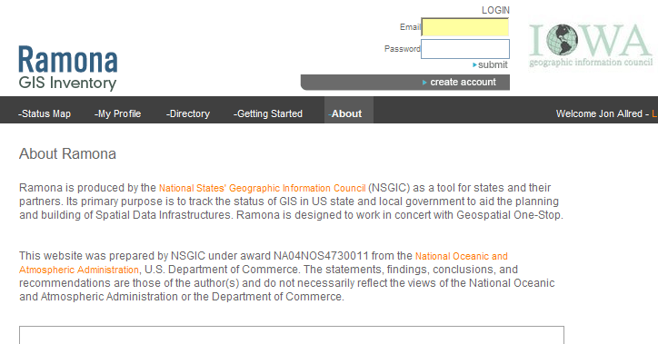
- The evolving Federal role in GIS is evident in state clearinghouses by links to RAMONA (graphic below), NSDI and FGDC and to more traditional map-using agencies such as the USGS, FEMA and NOAA. Iowa was particular in pointing toward the Geospatial One-Stop;

Source: http://ia.gisinventory.net/about.html, accessed December 7, 2006.

- State government-based clearinghouses tend to reflect geography and culture: Montana is heavily oriented to outdoor recreation and mineral resources while market analysis of farm manure is prominent at the Georgia clearinghouse. Not surprisingly, Hawaii and Oregon provide substantial data on tsunami risks;

- Among all states, this investigation found that ESRI shapefile™ data may be accessed most quickly through the Pennsylvania GIS clearinghouse, owing to the use of ArcIMS™ for direct loading to ArcMap™;

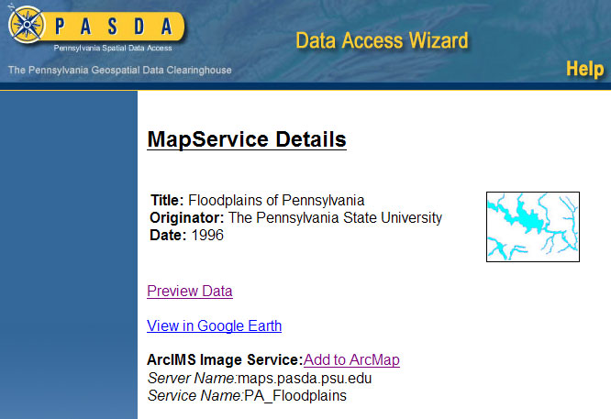
Source: http://cegis2.cas.psu.edu/uci/MapService.aspx?Dataset=11, accessed December 7, 2006.

- Nearly all clearinghouses provide metadata, although some are much more explicit than others about compliance with FGDC standards;

- A total of 20 states provide Web sites clearly designated as more or less official GIS clearinghouses; 37 states provide ESRI shapefile™ data, but in only 18 states are there shapefiles™ for topics meaningfully oriented to emergency response;

- A total of 12 states provide a basis for user participation in clearinghouse development; no states provide real-time interactivity for use during community emergencies;

- A few states, including New York and Virginia, appear either insular, if not provincial, by focusing on data security and access restrictions;

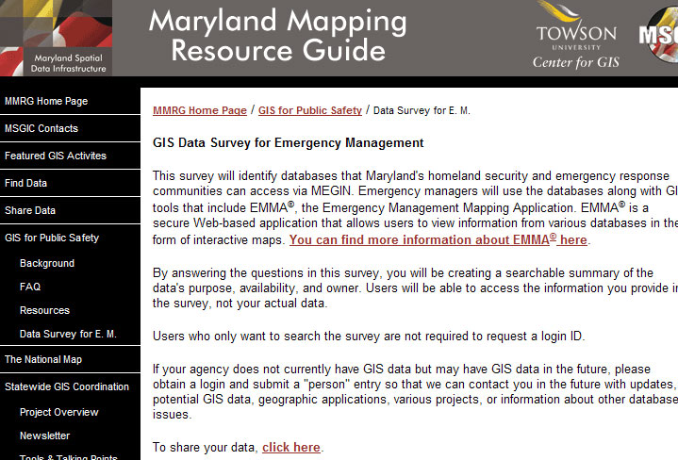
- GIS problems are still framed by available data. For instance, queries for emergency management data are largely fruitless as clearinghouses tend to be organized around the sources of data, rather than uses. A few state government-based clearinghouses are oriented to management problems, rather than data themselves, resulting in faster data searches. Maryland (illustration below) is exemplary in terms of explicit reference to data applications;
Source: http://www.marylandgis.net/coordination/
Source: http://www.marylandgis.net/emergencyMgmt.jsp, accessed December 7, 2006.

- Web-based data purveyors abound on the Web, including private, for-profit and non-profit, non-governmental and educational entities, too numerous to explore but worth noting here;

- State agencies, as GIS clearinghouses, vary tremendously in Website design, method of data access and content, suggesting potential value in promoting uniform Web standards for clearinghouses;

- GIS clearinghouses are primarily state agencies although several are either based on, or dominated by universities;

- Nearly all clearinghouses make metadata resources explicit, although metadata content varies widely as does the use of metadata as search tools;

- The use of icons and other Web symbols suggests the collapse of language and cultural barriers to data access. Clearinghouses that are slower or more difficult to navigate typically rely more on verbal instructions rather than intuitive symbols. In some cases, user guides are very helpful, amounting to tacit GIS and Web tutorials;

- Some clearinghouses require prior client registration and a few require some form of application for approval and/or fees for service;

- Web-based GIS service is inherently automated. All clearinghouses provide e-mail and/or voice contacts for assistance as a minor adjunct. There is little apparent correlation between the population base of each U.S. state and the richness of data, accessibility or range of services offered;

- Broken Web links, displaced Web sites and other technical problems are common and, for certain clearinghouses, impede data access. Surprisingly, a large number of clearinghouses provide white papers, calendars and other Web tools that are substantially out-of-date, including public events that happened as long as five years ago;

- Predictably, nearly all clearinghouses provide ESRI shapefile™ data; however, technical problems, such as client registration requirements, prevent downloading in some cases.

Conclusions

Attempting to access GIS clearinghouses under constrained conditions provides a broad overview of varying strengths among GIS clearinghouses, and suggests opportunities for improving GIS readiness as a tool for community emergency response. Such conditions apply to planning for, and responding to community emergencies. The Federal presence in GIS and emergency management is compelling: a large plurality of spatial data is based on traditional federal mapping resources, and the ‘One-Stop’ concept is enhanced by explicit orientation to user participation. The gravitational pull of National Map interests begs the value of state-level, non-governmental and fee-based services, particularly considering vast differences in content, style and orientation to rapid, two-way data transmission. In any case, citizens can access vast libraries of complex spatial information in a nearly seamless way, at no monetary cost and without practical restriction of use. The proliferation of mobile, spatial-capable communication devices portends a widening role for GIS on a non-technical basis. The real question is how to organize general public participation in spatial resource development.

References

All sources used in this paper are referenced as footnotes in the body and in tables below. A Web page by the author provides a further backdrop for considering GIS in community emergency response planning.

Table 1 - Results of Querying Apparent State GIS Clearinghouses for Project-Related ESRI Shapefiles
State | Official GIS | Shapefile | Desired | Immediate | Upload | Free of | Explicit | Load
State | Clearinghouse | Available | Target | Download | Capability | Cost | Metadata | Success
Alabama | not found | not found | no | not found | not found | no
Alaska | yes | not found | no | not found | yes | no | yes | no
Arizona | yes | yes | yes | yes | not found | yes | yes | yes
Arkansas | yes | yes | yes | yes | yes | yes | yes | yes
California | yes | yes | no | yes | yes | yes | yes | no
Colorado | yes | yes | no | yes | not found | yes | yes | yes
Connecticut | not as such | yes | no | yes | not found | yes | yes | yes
Delaware | yes | yes | yes | yes | not found | yes | yes | yes
Florida | not as such | yes | no | yes | not found | yes | yes | yes
Georgia | yes | yes | no | yes | not found | yes | yes | yes
Hawaii | yes | yes | yes | yes | not found | yes | yes | yes
Idaho | not as such | yes | yes | yes | yes | yes | yes | yes
Illinois | not as such | yes | no | yes | not found | yes | yes | partial
Indiana | not as such | not found | no | yes | not found | yes | yes | partial
Iowa | yes | yes | no | yes | not found | yes | yes | yes
Kansas | yes | yes | yes | yes | not found | yes | yes | yes
Kentucky | probably | yes | yes | yes | not found | yes | yes | yes
Louisiana | probably | yes | no | yes | not found | yes | yes | yes
Maine | not as such | yes | yes | yes | not found | yes | yes | yes
Maryland | probably | yes | yes | yes | yes | yes | yes | yes
Massachusetts | probably | yes | yes | yes | not found | yes | yes | yes
Michigan | probably | yes | yes | yes | yes | yes | yes | yes
Minnesota | yes | yes | no | yes | not found | yes | yes | yes
Mississippi | probably | yes | no | yes | not found | yes | yes | yes
Missouri | probably | yes | no | not found | not found | yes | yes | no
Montana | yes | yes | no | yes | not found | yes | yes | yes
Nebraska | yes | yes | no | yes | not found | yes | yes | yes
Nevada | yes | yes | no | yes | not found | yes | yes | yes
New Hampshire | possibly | not found | no | not found | not found | yes | yes | no
New Jersey | probably | yes | no | yes | not found | yes | yes | yes
New Mexico | yes | yes | no | yes | not found | yes | yes | yes
New York | yes | not found | no | not found | not found | unknown |  | no
North Carolina | yes | not found | no | not found | not found | unknown |  | no
North Dakota | probably | not found | no | not found | yes | yes | yes | no
Ohio | possibly | not found | no | not found | unknown | yes | yes | no
Oklahoma | probably | yes | yes | yes | not found | yes | yes | yes
Oregon | not as such | yes | yes | yes | not found | yes | yes | yes
Pennsylvania | yes | ArcMap | yes | yes | yes | yes | yes | yes
Rhode Island | probably | yes | yes | yes | yes | yes | yes | yes
South Carolina | possibly | not found | no | not found | yes | yes | yes | no
South Dakota | possibly | no access | no | no access | unknown | unknown |  | no
Texas | probably | yes | no | yes | not found | yes | yes | yes
Tennessee | possibly | yes | no | yes | not found | yes | yes | yes
Utah | yes | yes | yes | yes | not found | yes | yes | yes
Vermont | probable | yes | yes | yes | not found | yes | yes | yes
Virginia | probable | no | no | no | not found | unknown |  | no
Washington | yes | no | no | no | yes | unknown |  | no
West Virginia | probable | yes | yes | yes | not found | yes | yes | yes
Wisconsin | probable | yes | no | yes | not found | yes | yes | yes
Wyoming | yes | yes | no | yes | yes | yes | yes | yes

Table 2 - Web Address of Apparent Best State-Supported GIS Clearinghouse
Alabama | http://www.ag.auburn.edu/agrn/alric/**
Alaska | http://www.asgdc.state.ak.us/
Arizona | http://agic.az.gov/
Arkansas | http://www.gis.state.ar.us/AGIO_index.htm
California | http://gis.ca.gov/meta.epl?oid=5573
Colorado | http://www.dola.state.co.us/demog/GIS/Index.htm
Connecticut | http://magic.lib.uconn.edu/
Delaware | http://www.state.de.us/planning/dgdc/
Florida | http://www.gis-data.blogspot.com/
Georgia | https://gis1.state.ga.us
Hawaii | http://www.hawaii.gov/dbedt/gis/
Idaho | http://www.idwr.idaho.gov/gisdata/gis_data.htm
Illinois | http://www.isgs.uiuc.edu/
Indiana | http://www.in.gov/igic/projects/indianamap/data.html
Iowa | http://www.iowagic.org/
Kansas | http://www.kansasgis.org/catalog/catalog.cfm
Kentucky | http://ogi.ky.gov/gisdata.htm
Louisiana | http://atlas.lsu.edu/search/
Maine | http://apollo.ogis.state.me.us/
Maryland | http://www.marylandgis.net/coordination/
Massachusetts | http://www.mass.gov/mgis/ftpq3.htm
Michigan | http://www.mcgi.state.mi.us/mgdl/
Minnesota | http://geogateway.state.mn.us/documents/index.html?
Mississippi | http://www.maris.state.ms.us/
Missouri | http://msdisweb.missouri.edu/
Montana | http://nris.mt.gov/gis/
Nebraska | http://www.dnr.ne.gov/databank/geospatial.html
Nevada | http://www.nbmg.unr.edu/geoinfo/geoinfo.htm
New Hampshire | http://www2.des.state.nh.us/gis/onestop/
New Jersey | https://njgin.state.nj.us/NJ_NJGINExplorer/index.jsp
New Mexico | http://rgis.unm.edu/clearinghouse.cfm
New York | http://www.nysgis.state.ny.us/
North Carolina | http://www.cgia.state.nc.us/
North Dakota | http://www.nd.gov/gis/mapsdata/
Ohio | http://oit.ohio.gov/SDD/ESS/Ogrip/Index.aspx
Oklahoma | http://okmaps.onenet.net/digital_data.htm
Oregon | http://www.oregon.gov/DAS/EISPD/GEO/index.shtml
Pennsylvania | http://www.pasda.psu.edu/
Rhode Island | http://www.edc.uri.edu/rigis/
South Carolina | http://www.scmapping.net/smac.htm
South Dakota | http://www.sdgs.usd.edu/register/index.html
Texas | http://www.tnris.org/
Tennessee | http://www.tngic.org/
Utah | http://agrc.utah.gov/index.html
Vermont | http://www.vcgi.org/
Virginia | http://www.vgin.virginia.gov/SOTECH_GIS/SOTECH_index.htm
Washington | http://metadata.gis.washington.edu/
West Virginia | http://wvgis.wvu.edu/data/data.php
Wisconsin | http://www.sco.wisc.edu/wisclinc/findgeodata.php
Wyoming | http://www.sdvc.uwyo.edu/clearinghouse/
Source: All Web references are author’s original findings. **Note: The apparent best GIS clearinghouse sponsored by the State of Alabama was accessed through a Web site for GIS resources for New York State.

Geographic information systems, hardware and software for performing geographic or spatial analysis.
Global positioning system, a worldwide network of space-based satellites and ground stations used for determining location.
A ‘shapefile’ is a digital electronic file in a format used by Environmental Systems Research Institute, a for-profit GIS company that dominates the industry.
ArcMap is ESRI proprietary GIS software for performing spatial analysis.
National Spatial Data Infrastructure, a Federal initiative, including the “Fifty States Initiative” (http://www.nsgic.org/hottopics/50states_initiative_handout.pdf)
Federal Geographic Data Committee, appointed to consider GIS data standards.
United States Geological Survey,
Federal Emergency Management Agency, cited at http://www.fema.gov/mitigationss/brief.do?mitssId=1526
National Oceanic and Atmospheric Administration
http://gos2.geodata.gov/wps/portal/gos
Arguably, data security and integrity, as well as issues of national security, may work against open data access, for which some reference is made by the State of New York GIS clearinghouse, cited at http://www.nysgis.state.ny.us/mapssales/index.htm, accessed December 7, 2006.
Includes, among others, ESRI, Kellysearch (cited at www.kellsearch.com/us-al-product-44654.html. Cornell University (cited at http://www.library.cornell.edu/olinuris/ref/maps/usdata.html), National Geographic Map Machine, cited at http://plasma.nationalgeographic.com/mapmachine/index.html, accessed December 1, 2006. http://news.nationalgeographic.com/news/2001/04/0430_mapping.html), Wikipedia,
FirstGov.gov, at www.geodata.gov, accessed December 2, 2006.

